Volume: xx Issues: xx [xxxx, xxxx] pp.xx-xx]
Journal of XXXXXX (XXXXX)
eISSN: XXXX-XXXX
Journal website: www.XXXXX.com

TITLE (TNR, 16, BOLD, CENTER, SINGLE SPACING, UPPERCASE)

Adam^{1 (superscript)}
Amzar2 (^{superscript})
Hannah3 (^{superscript})
(TNR, 12, Bold, Centre, Single Spacing, Capitalize Each Word)

(^{superscript}) ¹Faculty Economic, Universiti Utara Malaysia (UUM), Malaysia, (E-mail: adam@uum.edu.my)
(^{superscript}) ²Faculty Account, Universiti Utara Malaysia (UUM), Malaysia, (Email: amzar@uum.edu.my)
(^{superscript}) ³Faculty Finance, Universiti Teknologi Mara (UiTM), Malaysia, (E-mail: hannah@uitm.edu.my)
(TNR, 10, Align Left, Capitalize Each Word)

Accepted date: xx-xx-xxxx
Published date: xx-xx-xxxx

To cite this document: Adam, Amzar & Hannah (2018). Tajuk. Journal of Islamic, Social, Economics and Development (JISED), x(xx), xx-xx.
__________________________________________________________________________________________

Abstract: (TNR, 12, italic, justify, single spacing) - The abstract should not more than 300 words each. The abstract should not only indicate the subject and scope of the manuscript, but also summarize the author’s conclusion. Structured abstract must be a brief, comprehensive summary of the contents of the manuscript. It allows readers to survey the contents of an article quickly. An Abstract summarizes the major aspects of a paper. It should succinctly summarize the purpose of the manuscript, the methods used, the major results, and conclusions.

Keywords: (TNR, 12, Italic, Justify, Single Spacing, Capitalize Each Word) - Min 3 Keywords and Max 5 Keywords
___________________________________________________________________________

Introduction – Heading 1 (TNR, 12, Bold, Align Left, Capitalize Each Word)
Tourism is one of the fastest growing development sectors in addition to other development strategic agendas such as energy, food, infrastructure ………….
(TNR, 12, single spacing, justify)

Literature Review – Heading 1 (TNR, 12, Bold, Align Left, Capitalize Each Word)
There are five point will be discussed in LR……
(TNR, 12, single spacing, justify)

Definition of Rural Tourism – Heading 2 (TNR, 12, Bold, Italic, Tab Inside, Capitalize Each Word)
Sustainable tourism as defined by The World Tourism Organization (UNWTO) is tourism that takes full account of current and future economic, social and environmental impacts…
(TNR, 12, single spacing, justify)

Rural Tourism – Heading 3 (TNR, 12, Bold, Italic, Tab Inside, Capitalize Each Word)
The goal of sustainable tourism is to reduce poverty, respect socio-cultural authenticity……
(TNR, 12, single spacing, justify)

Table 1: Example (TNR, 12, Single Spacing, Bold, Centre, Capitalize Each Word)
Example | Example | Example
Example | Example | Example
Example | Example | Example
Source: (TNR,10, Single Spacing, Align Left, Capitalize Each Word)

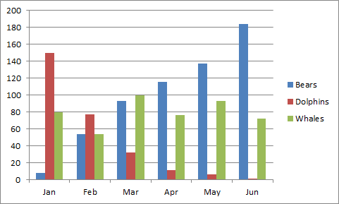
Figure 1: Example (TNR, 12, Single Spacing, Bold, Centre, Capitalize Each Word)
Source: (TNR,10, Single Spacing, Align Left, Capitalize Each Word)

References (APA Sixth Edition, Single Spacing)
Rohani M.M., & Yusoff, A. S. (2015). Tahap Kesediaan Pelajar Dalam Penggunaan Teknologi, Pedagogi, Dan Kandungan (TPACK) Dalam Pembelajaran Kurikulum di IPT. Proceeding of the 3rd International Conference on Artificial Intelligence and Computer Science, Pulau Pinang.
(Minimum references 15 (70% from published work)

Notes:
* Please remove any numbering on heading and subheading.
* Example for numbering figure are: Figure 1, Figure 2, Figure 3 ….so on.
* Example for numbering table are: Table 1, Table 2, Table 3 …….so on.
* Please refer above example for table and figure.
* Please remove the page number
* Margin Normal: Top (2.54cm), Bottom (2.54cm), Left (2.54cm), Right (2.54cm)
* Minimum Pages 6 & Maximum Pages 15
* Minimum reference 15 (70% from published work)

